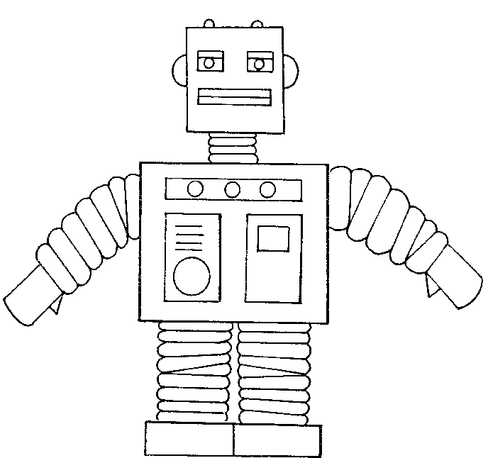
About FOSSopolis
FOSSopolis is a game where you play as a robot, running and jumping around the game world and beating up other bad robots. Sometimes you work together with other players who play their own little robots. Robots live in cities and all the robots are trying to build and establish their cities to keep them safe from evil robots who like to mess up the cities.

Combat Playtest
You are playing as the robot. I am playing as an evil robot, one of your enemies. I’m out to get you. We will take turns choosing attacks to use against one another. My attacks will be randomly determined through a dice roll. Your attacks will be determined by your own choice.
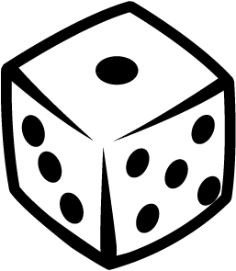
On your attack list you will see things like 1d6 or 3d6; these terms denote a dice roll with the d and the number of sides of the die after it. The number preceding the d is the number of said dice to be rolled.

Rules:
- We both have 100 health to begin
- Cooldowns are a waiting period that must pass for the player to use the attack again
- Some attacks have a secondary effect like stun and knock down
- I’ll keep track of health and attack history on this paper so we know when to attack again
- Stuns leave the enemy unable to attack for the amount of turns denoted
- Knock down leaves the enemy unable to attack. They can only be hit with low attacks.
- Counter forces the enemy to be unable to attack during his next turn. A random selection (1d3) will make the enemy receive double damage to a certain height.
- Secondary effects can stack, and still exist through a stun, knock down, or counter

